# **Database Management Lab file**

**In partial fulfillment of requirement for the degree**

**Of**

**Bachelor of Technology**

**In**

**COMPUTER SCIENCE**

**Submitted by**

**MAYANK BORA**

**(1816110110)**

**Under the supervision of**

**Mrs. Pavi Saraswat**

***Krishna Engineering college***

***Ghaziabad***



##### **DR. A.P.J. ABDUL KALAM TECHNICAL UNIVERSITY, LUCKNOW**

2020-2021

Table of Contents

EXPERIMENT – 1:

OBJECTIVE: Introduction to SQL. Also design SQL tables for Client & Product database and display all the values

Q1. Create the following tables?

Q2. Insert the following data into their respective tables?

EXPERIMENT – 2:

OBJECTIVE: Display the SQL Queries for command Select with Where clause.

Q3. On the basis of above two tables answer the following Questionnaires?

EXPERIMENT – 3:

OBJECTIVE: Create the SQL queries for commands like update, alter, rename, delete and drop.

Q1. Using the table client master and product master answer the following Questionnaires?

EXPERIMENT – 4:

OBJECTIVE: To Implement the restrictions on the table.

Q1. Create the following tables?

EXPERIMENT – 5:

OBJECTIVE: To Implement the structure of the table.

Q1. Create the following tables?

Q2. Insert the following values into the challan header and challan_details tables?

Q3. Using the table challan_header and challan_details answer the following Questionnaires?

**Experiment 4**

Objective: -To Implement the restrictions on the table.

Data constraints: Besides the cell name, cell length and cell data type there are other parameters i.e. other data constrains that can be passed to the DBA at check creation time. The constraints can either be placed at column level or at the table level.

Column Level Constraints: If the constraints are defined along with the column definition, it is called a column level constraint.

Table Level Constraints: If the data constraint attached to a specify cell in a table reference the contents of another cell in the table then the user will have to use table level constraints.

Null Value Concepts:- while creating tables if a row locks a data value for particular column that value is said to be null. Column of any data types may contain null values unless the column was defined as not null when the table was created.

Question.1 Create the following tables:

sales_master

|  |  |  |  |
| --- | --- | --- | --- |
| Column name | Data type | Size | Attributes |
| Salesman_no | varchar2 | 6 | Primary key/first letter must start with ‘s’ |
| Sal_name | varchar2 | 20 | Not null |
| Address | varchar2 |  | Not null |
| City | varchar2 | 20 |  |
| State | varchar2 | 20 |  |
| Pincode | Number | 6 |  |
| Sal_amt | Number | 8 | Not null, cannot be 0 |
| Tgt_to_get | Number | 6 | Not null, cannot be 0 |
| Ytd_sales | Number | 6 | Not null, cannot be 0 |
| Remarks | varchar2 | 30 |  |

QUERY:

create table sales_master_081(

Salesman_no varchar(6) primary key CHECK (Salesman_noLIKE 's'),

Sal_name varchar(20) NOT NULL,

Address varchar(20) NOT NULL,

City varchar(20), State varchar(20), Pincode int(6),

Sal_amt int(8) NOT NULL check(Sal_amt != 0),

Tgt_to_get int(6) NOT NULL check(Tgt_to_get != 0),

Ytd_sales int(6) NOT NULL check(Ytd_sales != 0),

Remarks varchar(30));

OUTPUT:

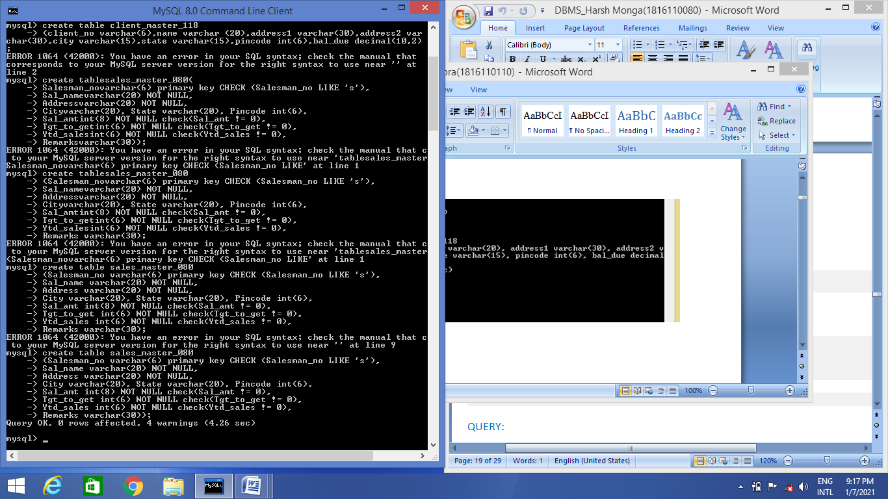

QUERY:

desc sales_master_080;

OUTPUT:

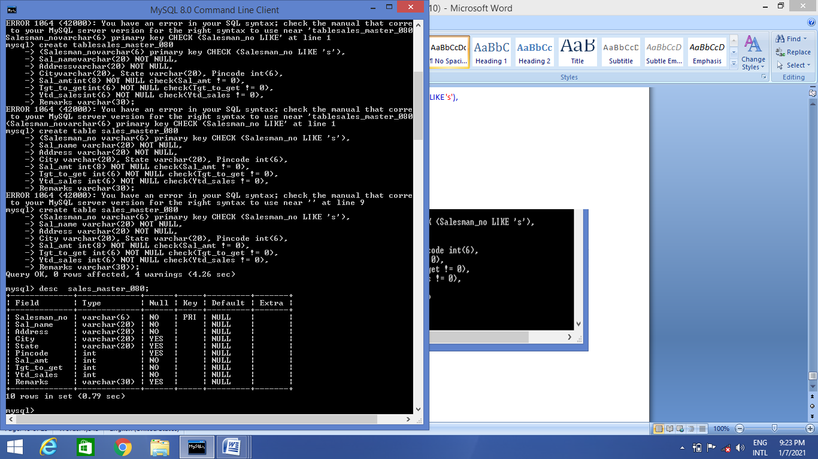

2.sales_order

|  |  |  |  |
| --- | --- | --- | --- |
| Columnname | Datatype | Size | Attributes |
| S_order_no | varchar2 | 6 | Primary/first letter must be 0 |
| S_order_date | Date | 6 | Primary key reference clientno of client_master table |
| Client_no | Varchar2 | 25 |  |
| Dely_add | Varchar2 | 6 |  |
| Salesman_no | Varchar2 | 6 | Foreign key references salesman_no of salesman_master table |
| Dely_type | Char | 1 | Delivery part(p)/full(f),default f |
| Billed_yn | Char | 1 |  |
| Dely_date | Date |  | Can not be lessthan s_order_date |
| Order_status | Varchar2 | 10 | Values (‘in process’;’fulfilled’;back order’;’canceled |

QUERY:

create table sales_order_080(

S_order_no varchar(6) PRIMARY KEY CHECK(s_order_no LIKE '0%'),

S_order_date DATE, Client_no varchar(25), Dely_add varchar(6),

Salesman_no varchar(6) REFERENCES sale_master(sales_no),

Dely_type varchar(1) CHECK(dely_type IN('p','f')) DEFAULT 'f',

billed_yn varchar(1), dely_date DATE,

order_status varchar(10) CHECK(order_status IN('in process','back order','cancelled'))

);

OUTPUT:

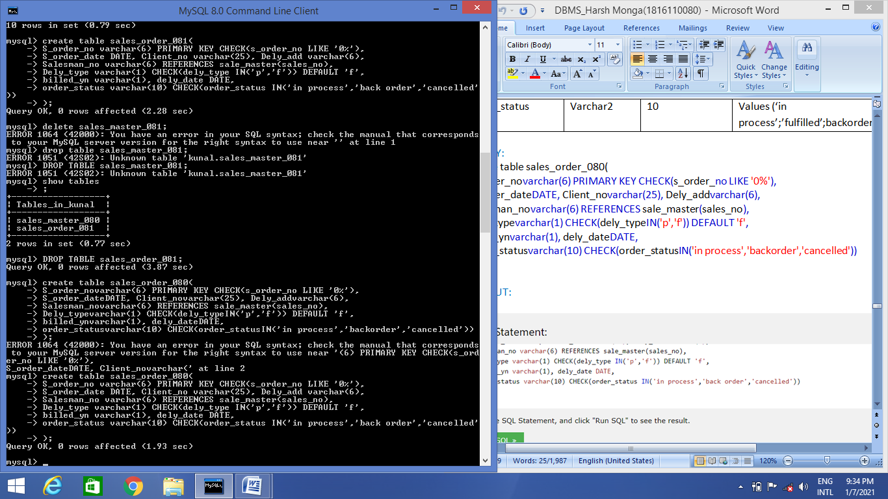

QUERY:

Desc table sales_order_080;

OUTPUT:

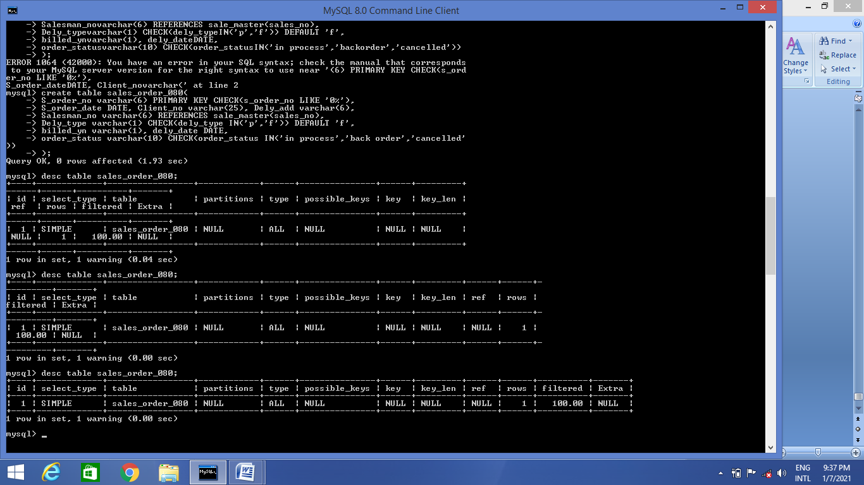

Sales_order_details

|  |  |  |  |
| --- | --- | --- | --- |
| Column | Datatype | Size | Attributes |
| S_order_no | Varchar2 | 6 | Primary key/foreign key references s_order_no of sales_order |
| Product_no | Varchar2 | 6 | Primary key/foreign key references product_no of product_master |
| Qty_order | Number | 8 |  |
| Qty_disp | Number | 8 |  |
| Product_rate | Number | 10,2 |  |

QUERY:

create table sales_order_details_080

(

s_order_novarchar(6) PRIMARY KEY REFERENCES sales_order(s_order_no),

product_novarchar(6) REFERENCES products(product_no),

qty_orderedint(8),

qty_dispint(8),

product_ratedecimal(10, 2)

);

OUTPUT:

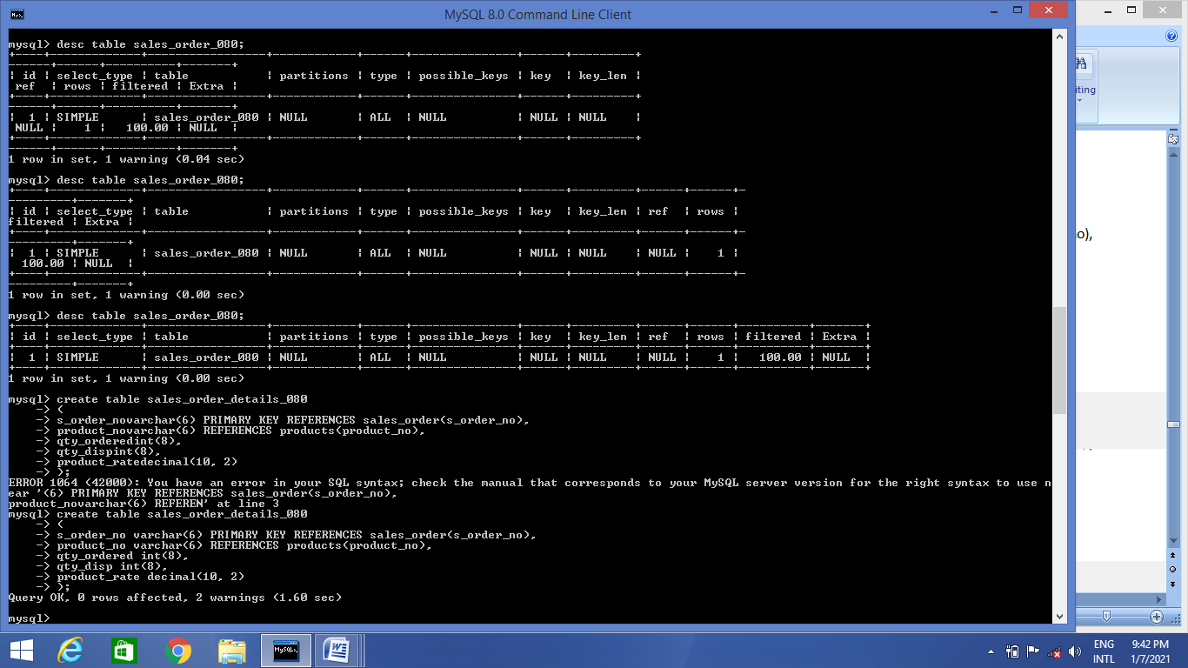

QUERY:

desc table sales_order_details_080;

OUTPUT

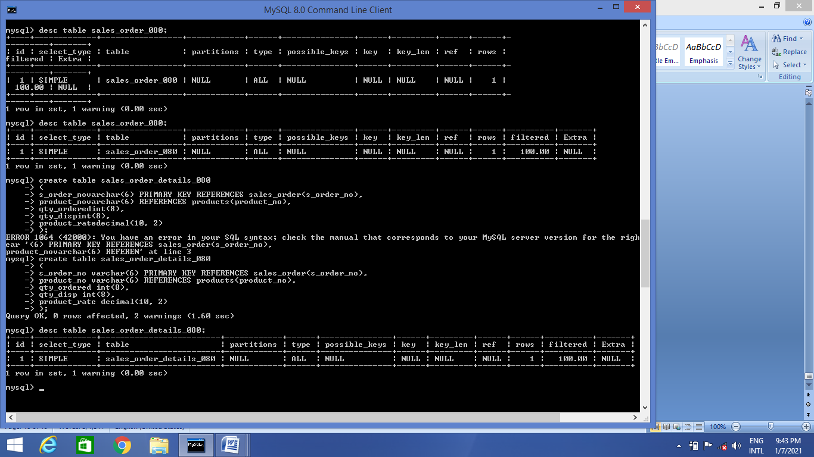

**Experiment 5**

**Objective** :- To Implement the structure of the table

**Theory: -**

**Modifying the Structure of Tables**- Alter table command is used to changing the structure of a table. Using the alter table clause you cannot perform the following tasks:

1. change the name of table
2. change the name of column
3. drop a column
4. decrease the size of a table if table data exists.

The following tasks you can perform through alter table command.

Adding new columns:

**Syntax :**

ALTER TABLE tablename

ADD (newcolumnnamenewdatatype (size));

Modifying existing table

**Syntax:**

ALTER TABLE tablename

MODIFY (newcolumnnamenewdatatype (size));

**Removing/Deleting Tables**- Following command is used for removing or deleting a table.

**Syntax:**

**DROP** TABLE tabename:

Defining Integrity constraints in the **ALTER** TABLE command-

You can also define integrity constraints using the constraint clause in the **ALTER** TABLE command. The following examples show the definitions of several integrity constraints.

Add PRIMARY KEY-

**Syntax:**

**ALTER** TABLE tablename

**ADD** PRIMARY KEY(columnname);

Add FOREIGN KEY-

**Syntax:**

**ALTER** TABLE tablename

**ADD** CONSTRAINT constraintname FOREIGN KEY(columnname) REFERENCES tablename;

Droping integrity constraints in the ALTER TABLE command:

You can drop integrity constraint if the rule that if enforces is no longer true or if the constraint is no longer needed. Drop the constraint using the **ALTER** TABLE command with the **DROP** clause. The following examples illustrate the droping of integrity constraints.

DROP the PRIMARY KEY-

**Syntax:**

ALTER TABLE tablename

DROP PRIMARY KEY

DROP FOREIGN KEY-

**Syntax:**

ALTER TABLE tablename DROP CONSTRAINT constraintname;

**Question 1. Create the following tables:**

**Challan_Header**

**Column name data type size Attributes**

Challan_no varchar2 6 Primary key

s_order_no varchar2 6 Foreign key references s_order_no of

sales_order table

challan_date date not null

billed_yn char 1 values (‘Y’,’N’). Default ‘N’

**Query:**

create table challan_header_080

(

challan_novarchar(6) PRIMARY KEY,

s_order_novarchar(12) REFERENCES sales_order(s_order_no),

challan_dateDATE,

billed_ynchar(1) CHECK(billed_ynIN('Y','N')) DEFAULT'N'

);

**Output:**

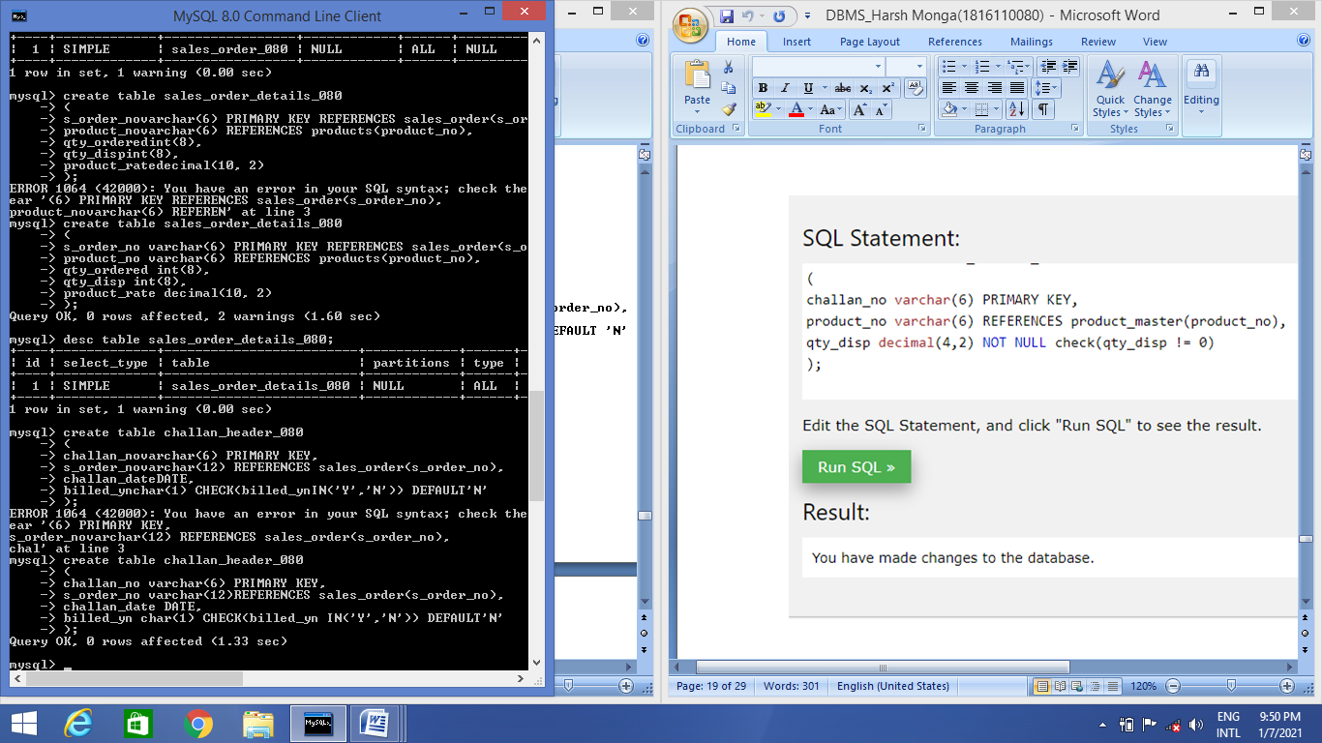

**Query:**

desc challan_header_080;

**Output:**

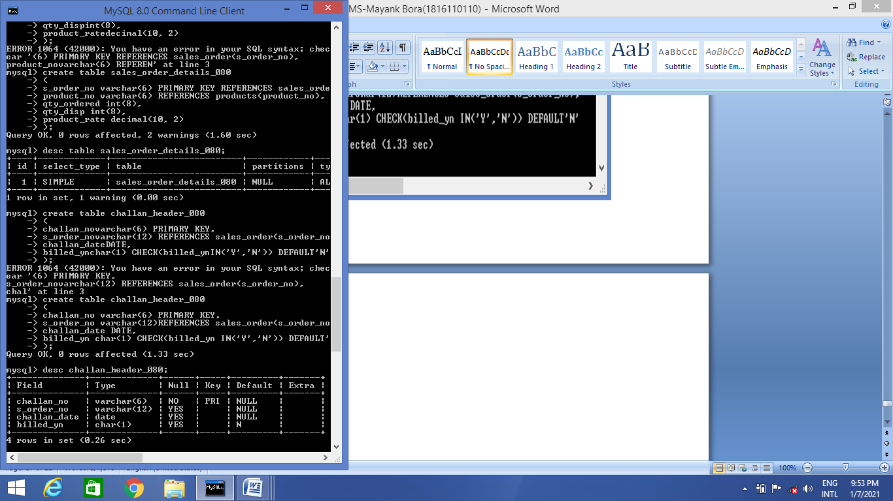

#### Table Name: Challan_Details

**Column name data type size Attributes**

challan_no varchar2 6 Primary key

product_no varchar2 6 Primary key/Foreign key references

product_no of product_master

qty_disp number 4,2 not null

**Query:**

create table challan_details_080

(

challan_no varchar(6) PRIMARY KEY,

product_no varchar(6) REFERENCES product_master(product_no),

qty_disp decimal(4,2) NOT NULL check(qty_disp != 0)

);

**Output:**

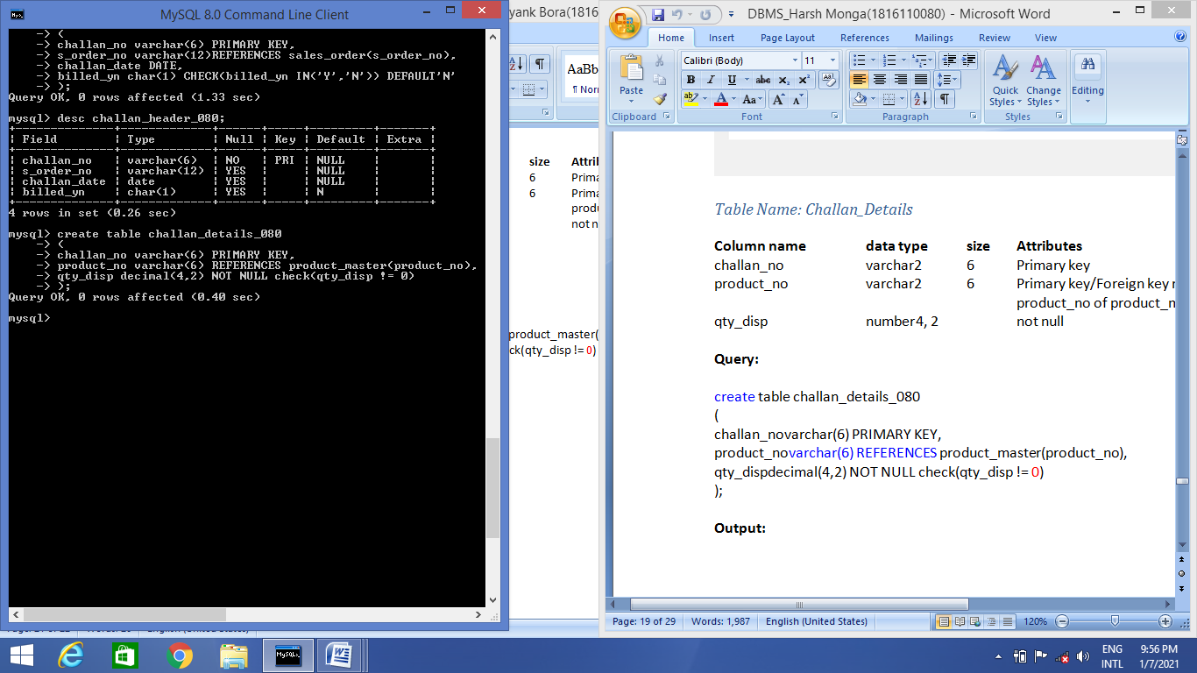

**Query:**

desc challan_details_080;

**Output:**

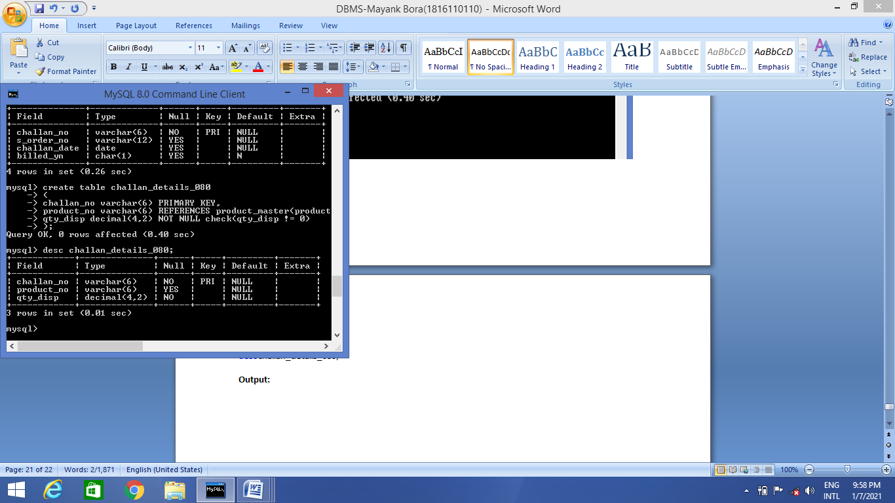

**Q2. Insert the following values into the challan header and challan_details tables:**

(i) **Challan No S_order No Challan Date Billed**

CH900 1019001 12-DEC-95 Y

CH865 046865 12-NOV-95 Y

CH396 5010008 12-OCT-95 Y

**Query:**

insert into challan_header_080

values row('CH900', '1019001', '95-12-12', 'Y'),

row('CH865', '046865', '95-11-12', 'Y'),

row('CH396', '5010008', '95-10-12', 'Y');

**Output:**

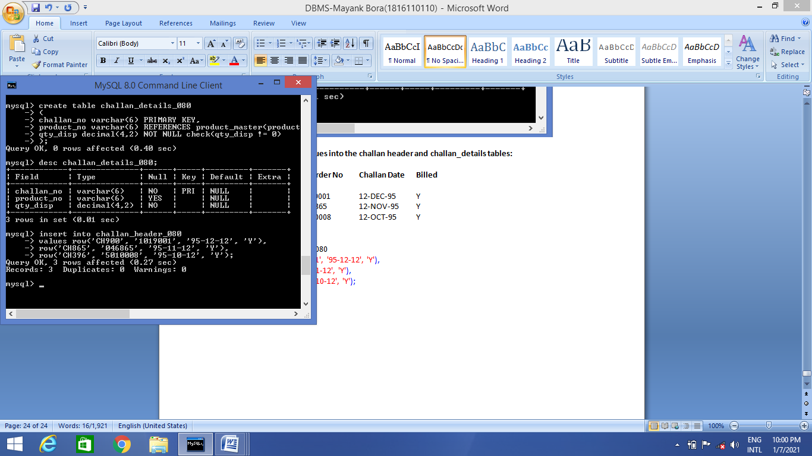

**Query:**

select * from challan_header_080;

**Output:**

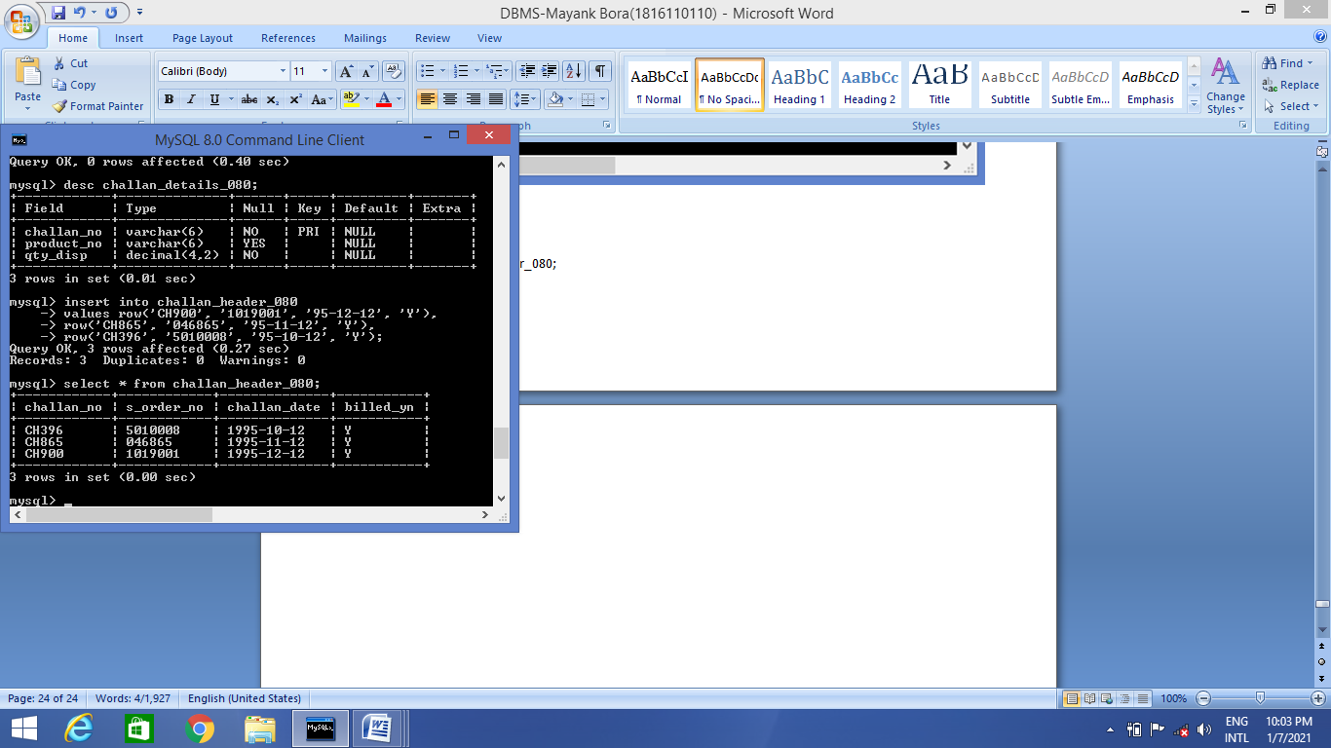

**Q3. Make the primary key to client_no in client_master.**

**Query:**

alter table client_master_118 add PRIMARY KEY(client_no);

**Output:**

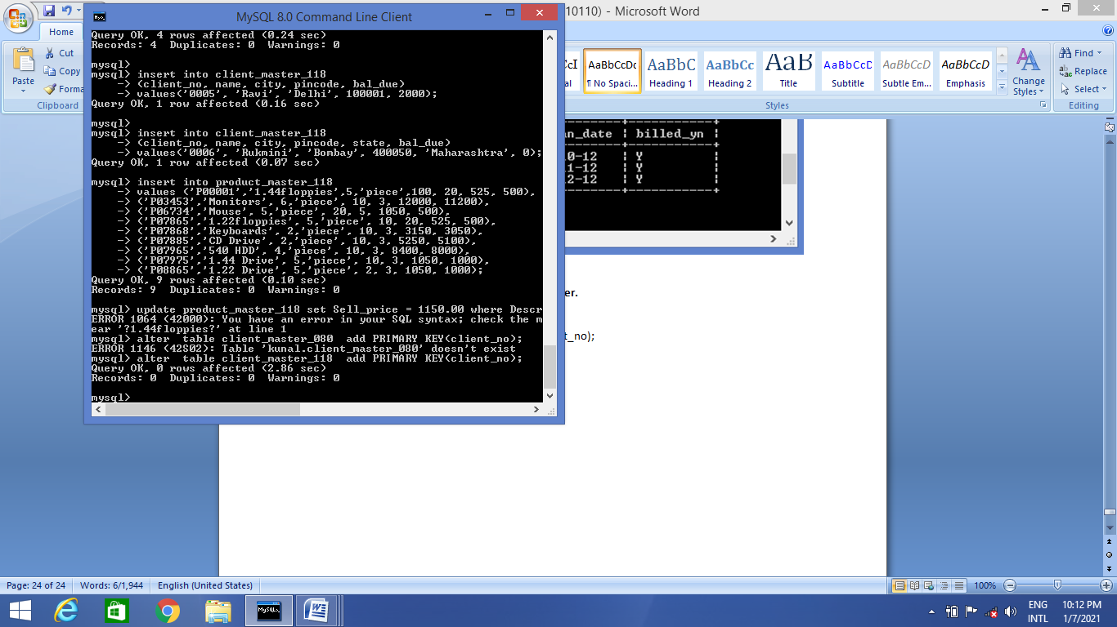

**Query:**

desc client_master_118;

**Output:**

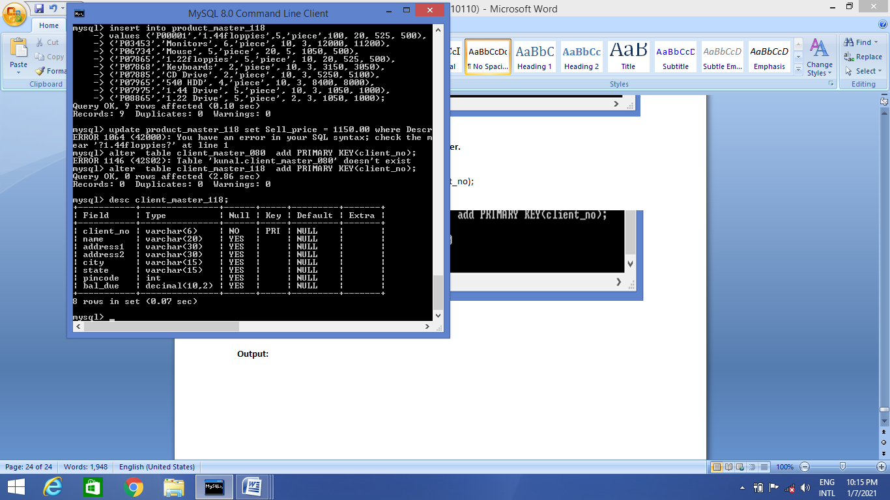

**Q4. Add a new column phone_no in the client_master table.**

**Query:**

alter table client_master_118 add phone_no int(11);

**Output:**

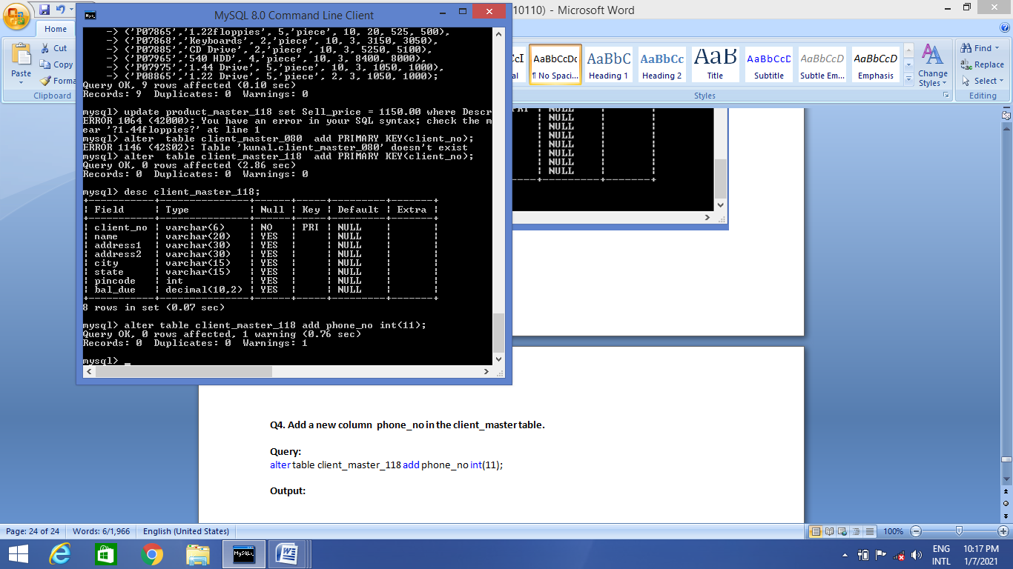

**Query:**

show columns from client_master_118 like ‘ph%’;

**Output:**

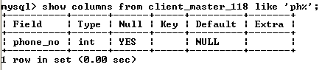

**Q5. Add the not null constraint in the product_master table with the columns description, profit percent, and sell price and cost price.**

**Query:**

alter table product_master_118 modify COLUMN Description varchar(25) NOT NULL;

alter table product_master_118modify COLUMN Profit_percent int NOT NULL;

alter table product_master_118 modify COLUMN Sell_price int NOT NULL;

alter table product_master_118 modify COLUMN Cost_price int NOT NULL;

**Output:**

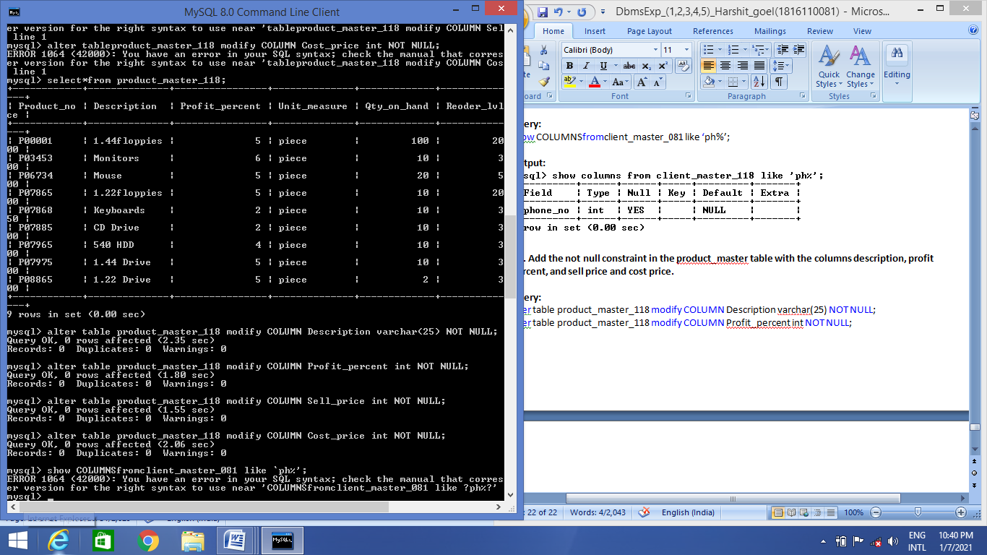

Query:

desc product_master_118;

Output:

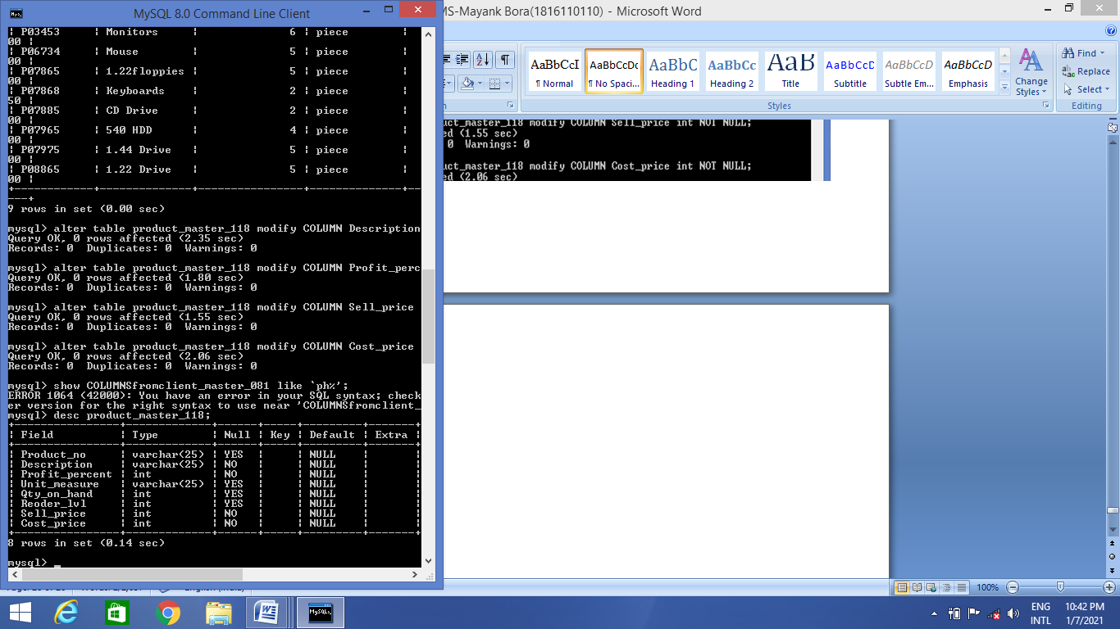

**Q6. Select product_no, description where profit percent is between 20 and 30 both inclusive.**

**Query:**

select Product_no, Description from product_master_118 where Profit_percent between 20 and 30 ;

Output:

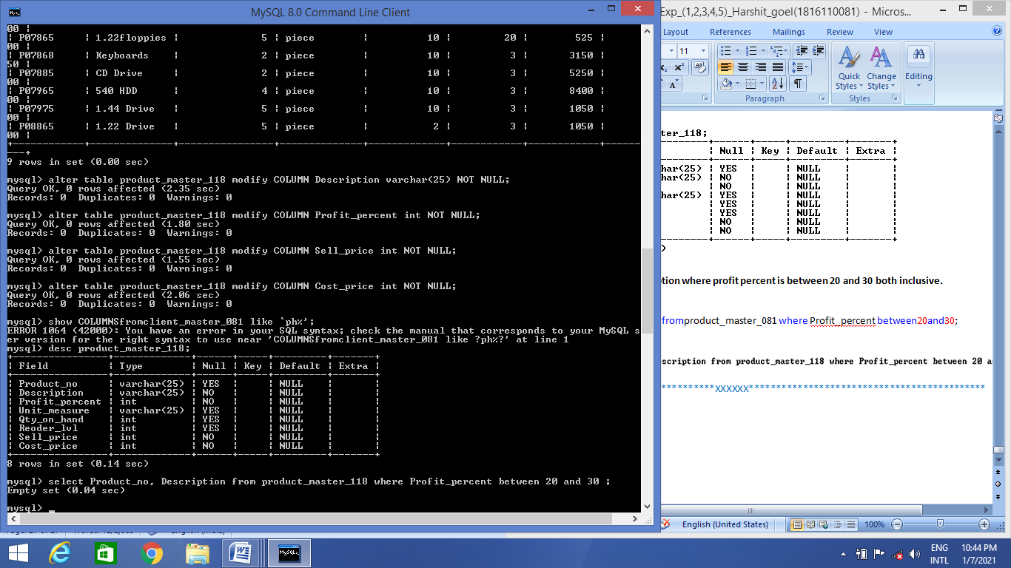

# **Complier Design Lab file**

**In partial fulfillment of requirement for the degree**

**Of**

**Bachelor of Technology**

**In**

**COMPUTER SCIENCE**

**Submitted by**

**MAYANK BORA**

**(1816110110)**



***Krishna Engineering college***

***Ghaziabad***



##### **DR. A.P.J. ABDUL KALAM TECHNICAL UNIVERSITY, LUCKNOW**

2020-2021